18.12: a) b) The van der Waals equation, which accounts for the attraction between molecules, gives a pressure that is 20% lower.
c) 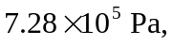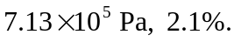 d) As 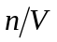 decreases, the formulas and the numerical values are the same.

